***AZURE TOPIC- MACHINE LEARNING***

It is a cloud-based platform that simplifies the machine learning lifecycle, from model building to deployment and management.

It provides a comprehensive environment for data scientists and developers to collaborate, train, deploy, and manage machine learning models.

Azure Machine Learning supports various frameworks like PyTorch, TensorFlow, and scikit-learn, and offers both automated machine learning and custom model development options.

***Machine learning basics***

Machine learning involves training models on data to enable them to make predictions or decisions without being explicitly programmed for every scenario.

The three main elements of a machine learning algorithm are representation, evaluation, and optimization.

* **Representation:** defines the structure of the model.
* **Evaluation:** measures the model's performance.
* **Optimization:** refers to the process of finding the best model parameters.

***Types of machine learning:-***

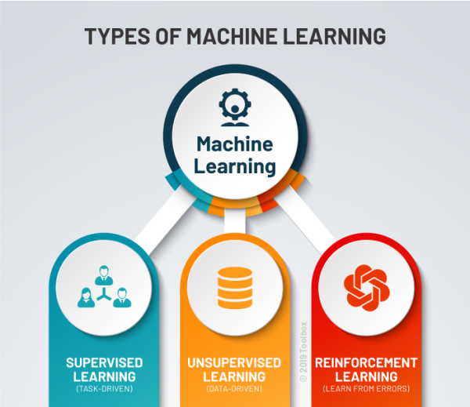

1. **Supervised Learning:** Algorithms learn from labeled datasets, where each input has a corresponding correct output. Example -Predicting categorical outputs (e.g., spam vs. not spam)
2. **Unsupervised Learning:** Algorithms work with unlabeled data to discover patterns and relationships independently. Example-Grouping similar data points together
3. **Reinforcement Learning (RL):** Algorithms learn by interacting with an environment, receiving rewards for desired actions and penalties for undesirable ones, aiming to maximize a long-term reward.

***Features:-***

• **MLOps:** Tools for managing, versioning, and automating the deployment and monitoring of ML models.

• **Automated ML (AutoML):** Automatically selects the best algorithms and tunes hyperparameters for efficient model building.

• **Designer:** A visual, drag-and-drop interface for building ML workflows without writing code.

• **Notebooks:** Integrated Jupyter notebooks for code-first development and experimentation.

• **Data Preparation & Feature Store:** Tools for data cleaning, transformation, and creating reusable features.

• **Responsible AI:** Capabilities for understanding, interpreting, and ensuring fairness in models.

• **Scalability & Compute:** Leverages Azure's cloud infrastructure for scalable training and deployment.

• **Model Deployment:** Simplifies deploying models as web services, batch jobs, or to edge devices.

***Enterprise-readiness &security:-***

Machine Learning integrates with the Azure cloud platform to add security to

ML projects.

Security integrations include:

* Azure Virtual Networks with network security groups.
* Azure Key Vault, where you can save security secrets, such as access

Information for storage accounts.

* Azure Container Registry set up behind a virtual network.

***Machine learning project workflow:-***

Typically, models are developed as part of a project with an objective and goals.  Projects often involve more than one person. When you experiment with data,  algorithms, and models, development is iterative.

**Project lifecycle**

The project lifecycle can vary by project, but it often looks like this diagram.

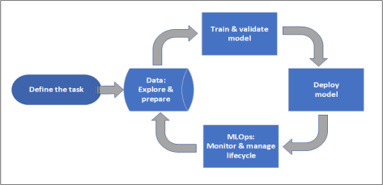

A workspace organizes a project and allows for collaboration for many users all working toward a common objective. Users in a workspace can easily share the results of their runs from experimentation in the studio user interface. Or they can use versioned assets for jobs like environments and storage references.

When a project is ready for operationalization, users' work can be automated in an ML pipeline and triggered on a schedule or HTTPS request.

You can deploy models to the managed inferencing solution, for both real-time and batch deployments, abstracting away the infrastructure management typically required for deploying models.

**Train models**

In Azure Machine Learning, you can run your training script in the cloud or build a model from scratch. Customers often bring models they've built and trained in open-source frameworks so that they can operationalize them in the cloud.

**Open and interoperable**

Data scientists can use models in Azure Machine Learning that they've created in common Python frameworks, such as:

* PyTorch
* TensorFlow
* scikit-learn
* XGBoost
* LightGBM

Other languages and frameworks are also supported:

* R
* .NET

**Deploy models**

To bring a model into production, you deploy the model. The Azure Machine Learning managed endpoints abstract the required infrastructure for both batch or real-time (online) model scoring (inferencing).

**MLOps: DevOps for machine learning**

DevOps for ML models, often called MLOps, is a process for developing models for production. A model's lifecycle from training to deployment must be auditable if not reproducible.

**ML model lifecycle**

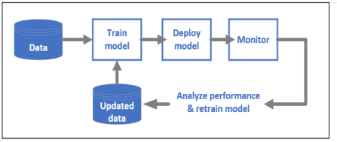

***Benefits:-***

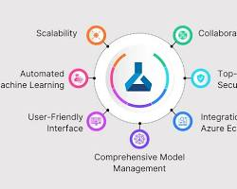

• **Scalability:** Azure ML allows you to effortlessly scale your machine learning workloads, from small experiments to large-scale training and deployment, adapting to your needs.

• **Collaboration Tools:** It offers features that enable data scientists and teams to work together efficiently on projects, sharing code, data, and models.

• **Automated Machine Learning:** This feature automates repetitive tasks in model building, such as algorithm selection and hyperparameter tuning, speeding up development.

• **Top-Notch Security:** Azure ML provides enterprise-grade security features to protect your data, models, and intellectual property throughout the ML lifecycle.

• **User-Friendly Interface:** It offers intuitive interfaces, including a visual designer and notebooks, making it accessible for users with varying levels of coding expertise.

• **Integration with Azure Ecosystem:** Azure ML seamlessly connects with other Microsoft Azure services, allowing you to leverage a wide range of cloud capabilities for your ML solutions.

• **Comprehensive Model Management:** The platform provides tools to manage the entire lifecycle of your machine learning models, from tracking experiments to versioning and deploying them.

***Limitations:-***

• **Can be costly:** For small projects, it might be more expensive than using free tools.

• **Hard to switch:** Once you're deep into using it, moving your work to another platform can be difficult.

• **Might be complex:** Learning all its advanced features can take some time, especially for beginners.